Mining Periodic Subgraphs in Drosophila Developmental Networks

Mohammad Shafiqul Islam
Department of Electrical and Computer Engineering
North South University
Dhaka, Bangladesh
mdshafiqul.islam@northsouth.edu
Mohammad Rafsun Jany Mahin
Department of Electrical and Computer Engineering
North South University
Dhaka, Bangladesh
jany.mahin@northsouth.edu
Ahsanur Rahman
Department of Electrical and Computer Engineering
North South University
Dhaka, Bangladesh
ahsanur.rahman@northsouth.edu

Abstract—For the past few years, periodic subgraph mining in dynamic networks has gained a lot of attention in different fields of research. However, not much work has been done in this regard in the field of network biology. This work attempts to fill this gap by finding subnetworks that appear periodically several times during Drosophila development. We first computed periodic subgraphs from a sequence of time varying gene networks using an existing tool. We suggested how to choose an appropriate parameter setting for this tool. We also did enrichment analysis of the largest connected component among those periodic subnetworks as well as the hub genes in it. Our results show that the proposed method can successfully identify periodically active gene-functions during the development of Drosophila. We have also compared our results with a baseline method which computes recurrent dense subgraphs in an ensemble of networks and found that the baseline method generates many spurious clusters irrelevant to the periodically active gene functions whereas our approach can successfully mine those functions.
Keywords—periodic subgraph, graph mining, Drosophila developmental networks, dynamic networks, functional enrichments

Introduction
In recent years, graph mining has attracted the attention of a lot of researchers. One of the main goals of graph mining is to find interesting patterns from one or more graphs. Such patterns include hubs [1], dense subgraphs [2], frequent dense subgraphs [3], periodic subgraphs [4], and so on. Different patterns are useful for different purposes. For example, hubs tend to indicate leaders in social networks and essential genes in protein-protein interaction (PPI) networks [5], dense subgraphs often reveal underlying communities in a social network [6], frequent dense subgraphs tend to indicate communities in a sequence of communication networks [7], periodic subgraphs tend to indicate periodically formed communities in dynamic social networks [4], etc.
Among them, periodic subgraph mining is one of the least studied problems. Especially, we couldn’t find any study that identifies periodic subgraphs in protein/gene interaction networks. It is not only an important research work to fill up this gap in the extant research work for its own sake but also the potential of periodic patterns to give us interesting insights of the underlying biology of the cell.
In fact, several previous studies have shown that some cellular processes may get periodically activated during organism development. Specifically, motoneurons exhibit periodic bursts of activities during the early development of spinal cord in chick and mouse [8]. These periodic bursts are produced and maintained by the developing synaptic network [8]. Also, during the development of mouse and other vertebrates, a transient neural network cause the generation of periodic waves of activities in the retina (known as retinal waves) [9]. These literature reviews suggested that some subnetworks of genes in the development networks may arise periodically in order to regulate of such periodic cues and/or as a response to such cues.

Periodic Subgraph Illustration
To understand the periodicity of a dynamic network, consider the graphs of Fig. 1 that is given below. This is an example of first six timesteps of Drosophila developmental network. For the purpose of simplicity, we have to use the connected network of the genes for each timestep. The reason to choose this particular network is this network has some highly biologically enriched genes (For example: Nrt, dock, brm, Src64B, and msn; all of them has high functional enrichment in neuron projection guidence). As these graphs are changing over the time, they can also be called time-varying networks.
Fig. 1 illustrates that, most of the interactions have occurred commonly in every timestep. From these networks, if we consider the subgraph {(CG3829, msn)}, it will have different periodicity based on our starting point. For example, when we start from T = 2, the period for that subgraph has to be at least two as at T = 5, there is no such edge. Again, if we start from T = 1, then the period can be one, as that subgraph has occurred in every timesteps from 1 to 4.
Another important concept of periodic subgraph is their support and support set. Support is the number of the total timesteps for a fixed period, and support set is the set of timesteps. For the above example, when we consider period two, the support is 3 as the subgraph exists at timesteps 2, 4, and 6. So the support set of this subgraph is {2, 4, 6} and its support is 3. Similarly, for period one, the support of this subgraph is 4 and its support set is {1, 2, 3, 4}.
There can be multiple subgraphs depending on the parameter (period, support) choice. So, we can say that a periodic subgraph in a collection of networks occurs s (support) times separated by p (period) timesteps.
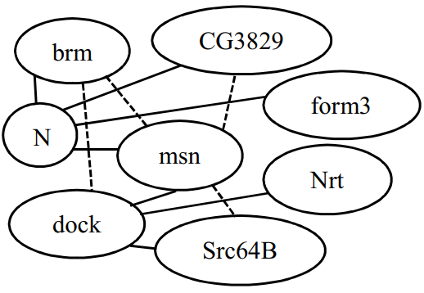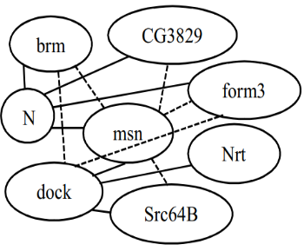
T = 1
T = 2

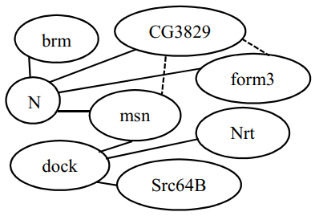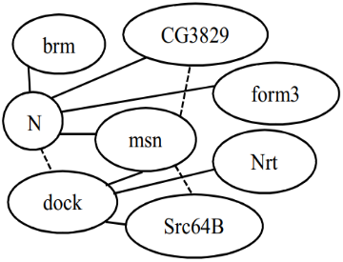
T = 3
T = 4

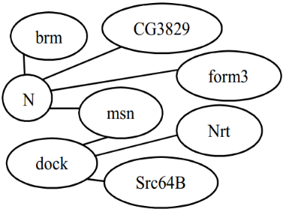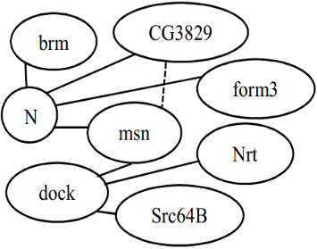
T = 5
T = 6

- Example of first six timesteps of Drosophila developmental network. Here, {(CG3829, msn)} is a periodic subgraph having period 2, support 3, and support set {2, 4, 6} starting from T = 2. The straight lines represents the edges that are not changing throughout the timesteps, where the dotted lines are changing.

Related Works
For the past few years, there are several works that has been done related to subgraph mining. Some are reviewed here in order to understand the different stages of our proposed methodology in this paper works. Another motivation to discuss the related works is to give an idea about how our work in this paper is different from those existing systems.
Lahiri and Berger-Wolf [4] developed a mining algorithm called PSEMiner which maintains a list of periodic subgraph for each timestep that has been read. This process continues up to the specified timestep T. Their algorithm had a time complexity of O((V+E)T³lnT) for vertex V, edge E when the parameter P_{max} (maximum periodicity) is not specified and O((V+E+P_{max}²) T²lnT) when P_{max} is specified. Their purpose was to find the least set of periodically recurring subgraphs that earn the periodic behavior in a dynamic network. They had also showed that it is better to use periodic subgraph in a system to characterize the nature of that system. They had experimented their algorithm in some social networks having datasets from Enron e-mails, Plain Zebra, Reality mining, IMDB celebrities, Server logs but not in the field of network biology.
In the next paper Apostolico, Barbares and Pizzi [10] were interested in finding the graphs that recur at regular interval. From all periodic graphs, their particular concern was in those that cannot be enriched by adding new edges without losing support. Later, they built an algorithm named ListMiner with time complexity O((E+V)(T² ln(T/σ)). The uniqueness of this algorithm is it does not need to know population in advance. So, it added the new incoming vertex online. The datasets and the experiments were exactly same as PSEMiner. They had compared the results of their algorithm with PSEMiner and concluded that their algorithm outperformed PSEMiner on both high and low density of the datasets. As ListMiner had a better result compared to PSEMiner, we have used ListMiner to find the periodic subgraphs for our network.
Bauer, Robinson and Gagneur [11] designed an approach called (MGSA) model-based gene set analysis that reduce the number of redundant categories returned by the gene category analysis. If the gene set is not in ranked lists, then functional enrichment can be found using MGSA algorithm. MGSA algorithm calculates a posterior probability and generally if the probability is greater than 0.4 then that gene set is highly enriched. We have used their MGSA model (Ontologizer) for some specific parameters to find highly enriched GO (gene ontology) term associated with MGSA score.
Next, a web application named FuncAssociate by Berriz, Beaver and Cenik [12], used for functional trend analysis. This tool is used to find gene-set enrichment that is used to characterize gene-sets (also known as query genes). Here, query genes are those genes which the researcher finds interesting from all genes that has been experimented by the researcher. FuncAssociate has two modes one is ordered another is unordered. In unordered mode FuncAssociate calculate the p-value for each GO term and if the p-value is low then it can be said that GO term is highly enriched. In ordered mode FuncAssociate takes the query genes as ordered list and calculates the GO term. We have used FuncAssociate several times to find the gene enrichment in our experiment.
Another related approach that was done by Li et al. [3], named NetsTensor. Using NetsTensor algorithm, it can be shown that some particular idea is not similar to other types of inspect on a graph. NetsTensor algorithm is used to find dense subgraph that are frequent. It also can find clusters for a specific size and specific frequency.

Dataset
We collected a dataset of time-varying networks [13] representing interaction among 588 genes during different stages of Drosophila development. It consists of total 66 temporal networks (timesteps) inferred from the expression of 588 genes involved in the development of Drosophila out of total 4028 genes. There are four different stages in these 66 networks along with the developmental cycle of Drosophila. The stages are Embryonic stage, Larval stage, Pupal stage, and Adult stage. The networks were estimated by kernel-reweighted logistic regression method (KELLER). It was applied to reverse engineer the networks between 588 genes from the expression values of the 4028 genes that were measured by Arbeitman et al. [14].
An edge between two genes in a network indicates that these genes are probably co-regulated at that time of the network. The contributing genes of an edge in a network are given as some numeric values. For example, an edge between the genes: spn-A and Borr is represented by 64 and 83 respectively.

Mining Methodology
Our proposed methodology for mining periodic subgraphs in Drosophila developmental networks consists of several stages. At first, we have done some preprocessing of the data. Then we choose a suitable period and support cut-offs to apply ListMiner algorithm to find the periodic subgraphs. After that, we have counted the number of genes for each parameter combination to find the suitable ones. Then we continued to the next step, finding the largest connected components for our selected parameters. Finally, we also have computed the functional enrichment of genes covered by these components to find the specific genes which are biologically enriched. We have used MATLAB and Python programing with other standalone applications such as Cytoscape, Funcassociate, Ontologizer, NetsTensor in different stages to generate the desired outputs.
Fig. 2 is a visual flowchart of the whole methodology.
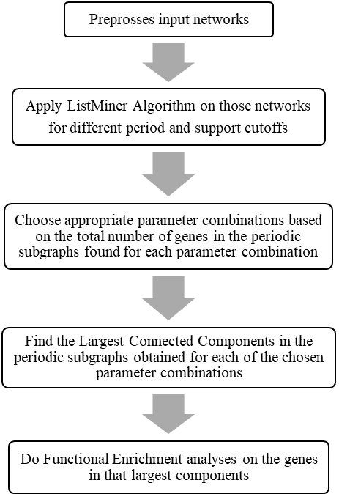
- Overview of Mining Methodolgy.

Data Preprocessing
As the format of the KELLER data and the input format of ListMiner algorithm do not match, some preprocessing works has to be done over the data.
We start with extracting the all edges of the networks individually. Then, all the edges of the 66 networks are copied to a single file and the duplicate edges are removed. As per the algorithm’s input requirement, we have to give a number starting from 589 to all the individual edges because 1 to 588 are the gene numbers. Finally, we sort all the edges according to the individual timesteps.
Fig. 3, Fig. 4, Fig. 5, and Fig. 6 respectively show a reflection of how the original KELLER data is transformed into ListMiner input format.
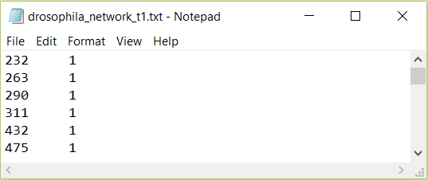

- Original KELLER data only for timestep 1 (partial) after extraction.
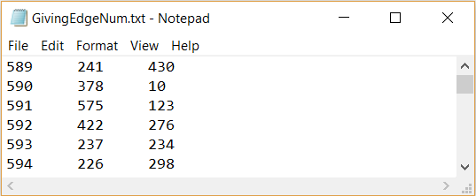

- Giving the edges number (partial).

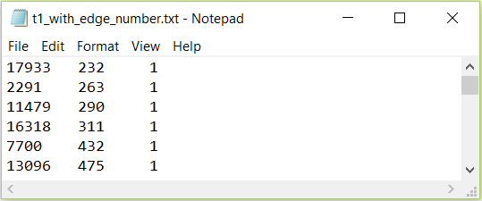
- Sorting the edges numbers for the timestep 1 (partial).

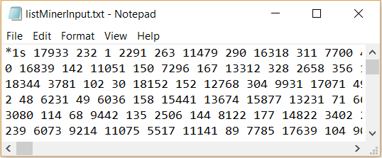
- Partial input for ListMiner (*1s means timestep 1).

Algorithm Apply
When the input format is ready, we apply the ListMiner algorithm to find the periodic subgraphs. We have slightly modified the algorithm as the requirement for different period and support cutoffs. For example, as there are total 66 developmental networks, we call the algorithm for period 2 to (66/3) and for every period, the support range is 3 to (66/period). From the output of the algorithm, we have multiple subgraphs for each parameter combination. Then, we have filtered out the edges and remapped the numeric values to Gene names accordingly. Fig. 7 is showing a partial output of the algorithm and Fig. 8 is the partial gene names representation.
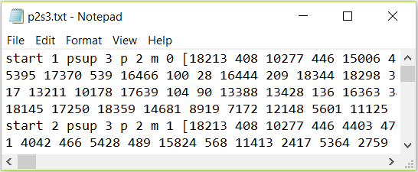

- Partial Output for period 2, support 3 after applying ListMiner. Here, start is the staring point (network/timestep) of the subgraph, psup means support, p means period, m means phase ( which is not needed for this research) and the square braces contain the subgraph. The first subgraph represents, it will be found in timesteps 1, 3, and 5 as the starting timestep is 1, the support is 3 and the period is 2.
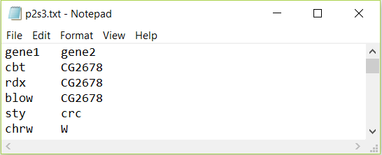

- Partial gene name representation of the subgraph for period 2, support 3.

Parameter Choosing
Although we have computed the periodic subgraphs for all possible parameter combination, all of them may not be significant for our further work as some of the parameters has very small number of subgraphs.
For choosing the right parameter, at first we create two 2d matrices. One of them shows the number of subgraphs for each combination of parameters. The other one shows the total number of unique genes covered by the subgraphs that we have found for each combination of parameters. Table. 1 displays first matrix which the number of periodic subgraphs. Here, empty cells represent that no periodic subgraph has been found for that parameter. We can see that the number of graphs are decreasing when the periods and supports both are increasing.
- Number of Periodic Subgraphs for Each Parameter Combination (partial)
Periods | Supports
Periods | 3 | 4 | 5 | 6 | 7 | 8 | 9
2 | 692 | 415 | 267 | 160 | 104 | 57 | 33
3 | 491 | 244 | 127 | 60 | 34 | 17 | 8
4 | 388 | 156 | 64 | 27 | 11 | 4 | 3
5 | 300 | 101 | 35 | 10 | 5
6 | 243 | 70 | 18 | 5
7 | 189 | 42 | 10
8 | 149 | 25 | 3
9 | 144 | 15

Table. 2 is the visual representation of the second matrix. It shows the number of unique genes for each parameter combination. Here, we again see that the number of unique genes are decreasing as long as the periods and supports are increasing. Another interesting finding is that the genes of a parameter are the subset of its ancestors (both period and support).
So, we have to choose the parameter in such a way that period, support, number of genes – none is too low. Here, period 2, support 8 and period 7, support 3 (the colored two cells) are the parameters that we have chosen. The motive for choosing these two is we want to consider the both cases which are, one parameter will have a small period but large support and the other one will be the vice versa.
- Number of Unique Genes Covered by the Subgraphs for Each Parameter (Partial)
Periods | Supports
Periods | 3 | 4 | 5 | 6 | 7 | 8 | 9
2 | 588 | 570 | 471 | 349 | 234 | 155 | 58
3 | 576 | 433 | 231 | 135 | 44 | 12 | 7
4 | 502 | 242 | 60 | 13 | 7 | 2 | 2
5 | 379 | 141 | 13 | 2 | 2
6 | 262 | 52 | 7 | 2
7 | 169 | 17 | 2
8 | 77 | 7 | 2
9 | 55 | 2

Largest Connected Component Finding
To extract highly enriched functional genes from the periodic subgraphs, we need to find the largest connected component out of the subgraphs of the chosen parameters. We have used Cytoscape to find the connected component of an individual subgraph where we have found multiple connected components. So, the largest connected component is chosen on the basis of largest number of unique genes.
For period 2 and support 8, we have 57 subgraphs. Among these 57 subgraphs, the largest connected component that we have found in a specific subgraph has the staring timestep 1. So this subgraph as well as the largest connected component will be found in timesteps 1, 3, 5, 7, 8, 9, 11, and 13. The largest connected component for this parameter has total 33 unique genes with 56 edges among 94 unique genes and 102 edges.
Then, for period 7 and support 3, we have the largest connected component with staring point 1 among total 189 subgraphs and the subgraph that has the largest connected component will be found in timesteps 1, 8, and 15. The largest connected component consists of 39 unique genes and 64 edges where the subgraph that contains the largest connected component has 103 unique genes and 112 edges.
Fig. 9 and Fig. 10 show these two largest connected component below respectively.

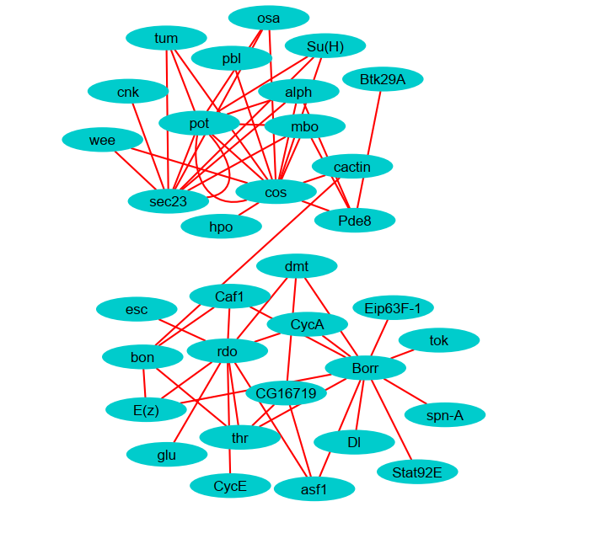
- Largest Connected Component for Period 2 and Support 8.
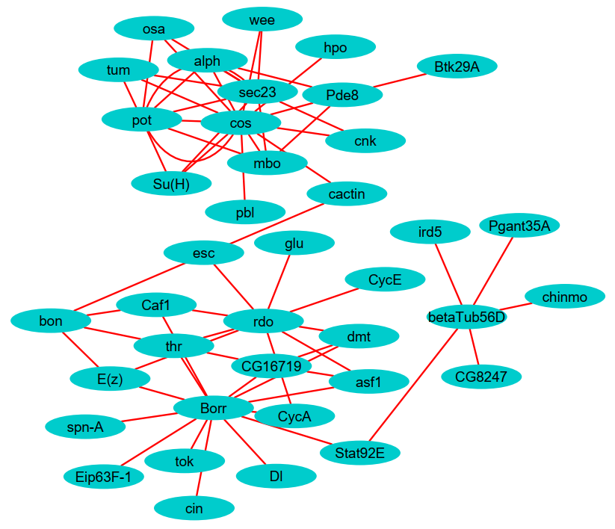

- Largest Connected Component for Period 7 and Support 3.

Functional Enrichment
We have converted the gene names to ensemble gene id namespace.

MGSA Enrichment
- MGSA Enrichment of the Largest Connected Component for Each Parameter
Parameters | Highly Enriched GO Term | MGSA Score (0~1)
Period 2, Support 8 | Chromosome Organization | 0.68
Period 2, Support 8 | CAF1 Complex | 0.64
Period 7, Support 3 | Chromosome Organization | 0.54
Period 7, Support 3 | CAF1 Complex | 0.60

Funcassociate Enrichment
- FuncAssociate enrichment of sorted (by degrees) list of nodes in the largest component
Highly Enriched GO Term | LOD ratio | Adjacent P-value
CAF1 Complex | 2.58 | 0.04
Nucleosome Assembly | 2.02 | 0.019
Protein-DNA Complex Assembly | 2.02 | 0.019
Chromatin Organization | 1.29 | 0.001

Result and Comparison

Conclusion

Future Work

Positioning Figures and Tables: Place figures and tables at the top and bottom of columns. Avoid placing them in the middle of columns. Large figures and tables may span across both columns. Figure captions should be below the figures; table heads should appear above the tables. Insert figures and tables after they are cited in the text. Use the abbreviation “Fig. 1”, even at the beginning of a sentence.
- Table Type Styles
Table Head | Table Column Head
Table Head | Table column subhead | Subhead | Subhead
copy | More table copyª
- Sample of a Table footnote. (Table footnote)
- Example of a figure caption. (figure caption)
Figure Labels: Use 8 point Times New Roman for Figure labels. Use words rather than symbols or abbreviations when writing Figure axis labels to avoid confusing the reader. As an example, write the quantity “Magnetization”, or “Magnetization, M”, not just “M”. If including units in the label, present them within parentheses. Do not label axes only with units. In the example, write “Magnetization (A/m)” or “Magnetization {A[m(1)]}”, not just “A/m”. Do not label axes with a ratio of quantities and units. For example, write “Temperature (K)”, not “Temperature/K”.

Acknowledgment (Heading 5)
The preferred spelling of the word “acknowledgment” in America is without an “e” after the “g”. Avoid the stilted expression “one of us (R. B. G.) thanks ...”. Instead, try “R. B. G. thanks...”. Put sponsor acknowledgments in the unnumbered footnote on the first page.

References
- Y. R. Cho and A. Zhang, “Identification of functional hubs and modules by converting interactome networks into hierarchical ordering of proteins,” BMC Bioinformatics, vol. 11, no. SUPPL. 3, 2010.
- H. Hu, X. Yan, Y. Huang, J. Han, and X. J. Zhou, “Mining coherent dense subgraphs across massive biological networks for functional discovery,” Bioinformatics, vol. 21, no. SUPPL. 1, pp. 213–221, 2005.
- W. Li, C. C. Liu, T. Zhang, H. Li, M. S. Waterman, and X. J. Zhou, “Integrative analysis of many weighted Co-Expression networks using tensor computation,” PLoS Comput. Biol., vol. 7, no. 6, 2011.
- M. Lahiri and T. Y. Berger-Wolf, “Periodic subgraph mining in dynamic networks,” Knowl. Inf. Syst., vol. 24, no. 3, pp. 467–497, Sep. 2010.
- N. Pržulj, D. A. Wigle, and I. Jurisica, “Functional topology in a network of protein interactions,” Bioinformatics, vol. 20, no. 3, pp. 340–348, 2004.
- J. Janssen and M. Hurshman, “Model Selection for Social Networks using Graphlets,” Internet Math., vol. 8, no. 4, pp. 338–363, 2012.
- C. C. Aggarwal, Y. Li, and P. S. Yu, “On Dense Pattern Mining in Graph Streams [ Extended Abstract ],” Vldb, pp. 975–984, 2010.
- M. J. O’Donovan, N. Chub, and P. Wenner, “Mechanisms of spontaneous activity in developing spinal networks,” J. Neurobiol., vol. 37, no. 1, pp. 131–145, Oct. 1998.
- K. J. Ford, A. L. Felix, and M. B. Feller, “Cellular Mechanisms Underlying Spatiotemporal Features of Cholinergic Retinal Waves,” J. Neurosci., vol. 32, no. 3, pp. 850–863, Jan. 2012.
- A. Apostolico, M. Barbares, and C. Pizzi, “Speedup for a periodic subgraph miner,” Inf. Process. Lett., vol. 111, no. 11, pp. 521–523, 2011.
- S. Bauer, P. N. Robinson, and J. Gagneur, “Model-based gene set analysis for bioconductor,” Bioinformatics, vol. 27, no. 13, pp. 1882–1883, 2011.
- G. F. Berriz, J. E. Beaver, C. Cenik, M. Tasan, and F. P. Roth, “Next generation software for functional trend analysis,” Bioinformatics, vol. 25, no. 22, pp. 3043–3044, 2009.
- L. Song, M. Kolar, and E. P. Xing, “KELLER: Estimating time-varying interactions between genes,” Bioinformatics, vol. 25, no. 12, pp. 128–136, 2009.
- M. N. Arbeitman et al., “Gene expression during the life cycle of Drosophila melanogaster.,” Science (80-. )., vol. 297, no. September, pp. 2270–5, 2002.

IEEE conference templates contain guidance text for composing and formatting conference papers. Please ensure that all template text is removed from your conference paper prior to submission to the conference. Failure to remove template text from your paper may result in your paper not being published.

We suggest that you use a text box to insert a graphic (which is ideally a 300 dpi TIFF or EPS file, with all fonts embedded) because, in an MSW document, this method is somewhat more stable than directly inserting a picture.
To have non-visible rules on your frame, use the MSWord “Format” pull-down menu, select Text Box > Colors and Lines to choose No Fill and No Line.

